** The University of Azad Jammu & Kashmir, Muzaffarabad**

**Computer Architecture & Logic Design**

|  |  |
| --- | --- |
| **Student Name:** | Shahzad Ahmed Awan |
| **Roll No:** | 2024-SE-15 |
| **Course Title:** | Computer Architecture & Logic Design |
| **Course Code:** | CS-1205 |
| **Instructor:** | Engr. Sidra Rafique |
| **Submission Date:** | 03-June -2025 |
| **Department of Software Engineering** | |

Lab 05: HALF ADDER IMPLEMENTATION

**Practical Implementation on Trainer (Using ICs)**

1. **Place the ICs on the breadboard**:
   * IC 7486 (XOR gate)
   * 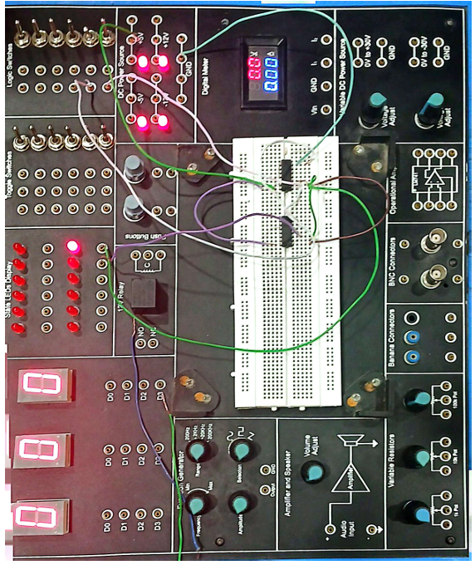IC 7408 (AND gate)
2. **Provide power connections**:
   * Connect **Vcc (pin 14)** and **GND (pin 7)** of both ICs.
3. **Connect input lines**:
   * Use two push-button switches or toggle switches for Input A and Input B.
   * Connect these inputs to corresponding pins of both ICs.
4. **Connect output lines**:
   * XOR output pin → LED for Sum
   * AND output pin → LED for Carry
5. **Use appropriate resistors** (typically 330Ω–1kΩ) in series with LEDs to prevent overcurrent.

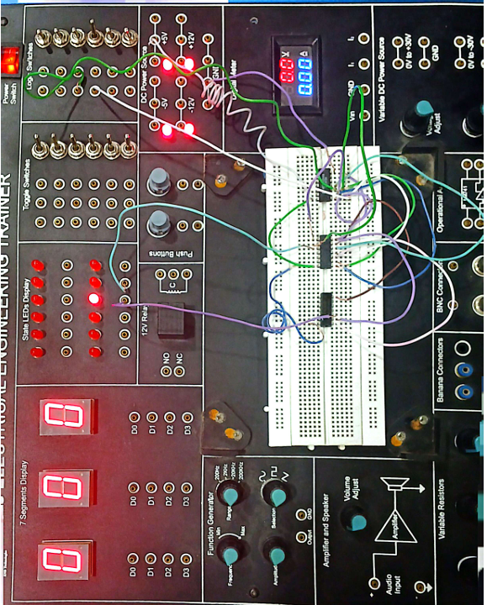

1. **Power the board** and toggle switches to test combinations:
   * 0 + 0 → Sum = 0, Carry = 0
   * 0 + 1 → Sum = 1, Carry = 0
   * 1 + 0 → Sum = 1, Carry = 0
   * 1 + 1 → Sum = 0, Carry = 1

**2. Implementation in Electronics Workbench (EWB)**

**Part A: Half Adder using Logic Gates**

**Components:**

* 2x SPST Switches
* 1x XOR Gate
* 1x AND Gate
* 2x LEDs
* Resistors (220Ω)
* Power Source (+5V)

**Steps:**

1. 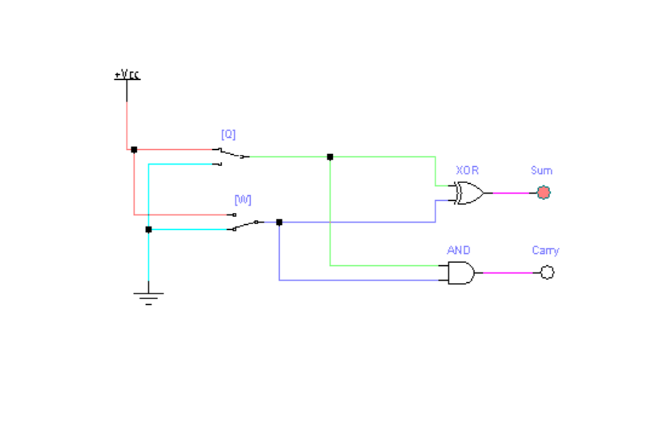Launch **EWB** and start a new project.
2. Drag and place two **SPST switches** labeled A and B.
3. Insert one **XOR gate** for **Sum output**.
4. Insert one **AND gate** for **Carry output**.
5. Connect:
   * Inputs A and B to both XOR and AND gates.

Figure 1: Gate Circuit of HALF ADDER

* + Output of XOR to **LED1** (Sum)
  + Output of AND to **LED2** (Carry)

1. Connect a **220Ω resistor** in series with each LED.
2. Attach LEDs to **ground** to complete the path.
3. Power the circuit with a **+5V** source.
4. 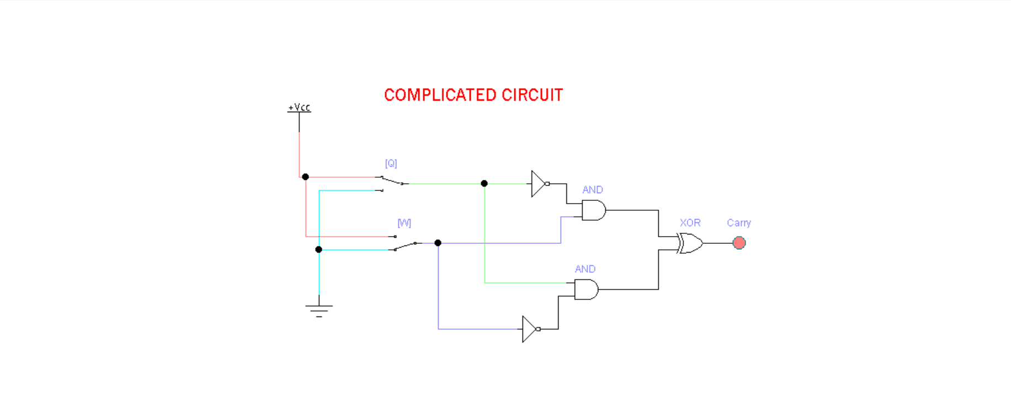Test all 4 input combinations (00, 01, 10, 11) using switches and verify the output with the truth table.

Figure 2: Complicated Circuit Diagram of Half Adder

**Part B: Half Adder using Digital ICs**

**ICs Used:**

* **IC 7486** → XOR Gate (for Sum)
* **IC 7408** → AND Gate (for Carry)

**Components:**

* IC 7486 (Quad XOR gate)
* IC 7408 (Quad AND gate)
* 2x SPST Switches
* 2x LEDs
* Resistors (220Ω)
* Breadboard (or simulated in EWB)
* Power Supply (+5V and GND)

**Steps:**

1. Place **IC 7486** and **IC 7408** in your circuit.
2. Connect **Pin 14** of both ICs to **+5V**, and **Pin 7** to **GND**.
3. Use:
   * **IC 7486 XOR gate 1** (pins 1, 2 → input; pin 3 → Sum output)
   * **IC 7408 AND gate 1** (pins 1, 2 → input; pin 3 → Carry output)
4. 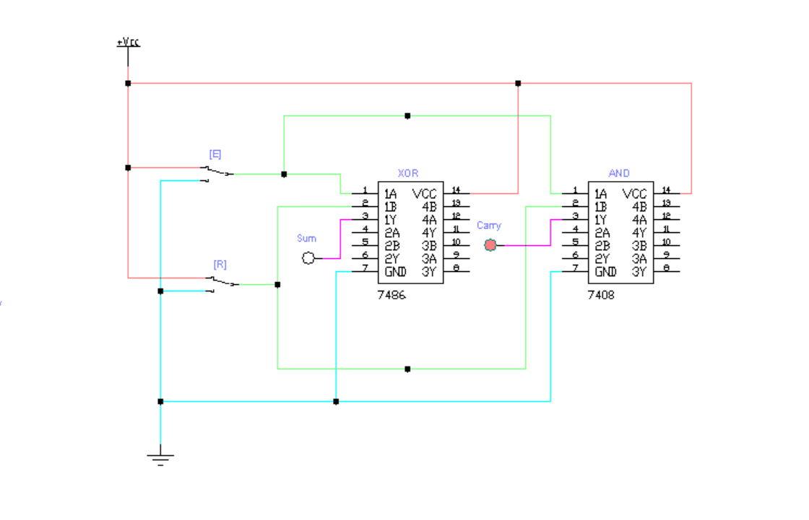Inputs A and B are connected to both XOR and AND inputs using SPST switches.
5. Outputs (Pin 3 from each IC) go to **LEDs** with 220Ω resistors.
6. Complete the LED connections to **ground**.

Figure 3: IC Circuit Implementation of HALF ADDER

1. Test the inputs by toggling switches and compare output LEDs with the **truth table**.

|  |  |  |  |
| --- | --- | --- | --- |
| A | B | Sum (A⊕B) | Carry (A·B) |
| 0 | 0 | 0 | 0 |
| 0 | 1 | 1 | 0 |
| 1 | 0 | 1 | 0 |
| 1 | 1 | 0 | 1 |

**Truth Table of Half Adder**